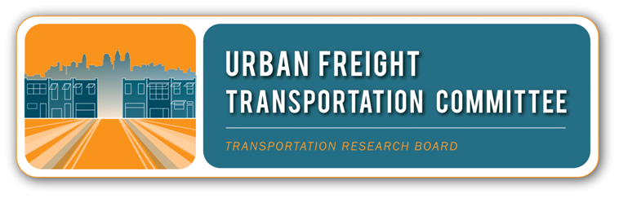
Dissemination of Innovations in Urban and Regional Freight:
A Researcher-Practitioner Dialogue
Design of UFTC Working Session: 13 January 2014, 3:45-5:30pm,
Capitol Room, Omni Shoreham, Washington, DC

- Outcome
Successful deployment of innovation demands a productive partnership of practitioners and researchers. The TRB Urban Freight Transportation Committee’s intent today is to get your help in identifying the most viable steps in promoting the adoption and active use of innovative practices in urban and regional freight. Our work together builds on the dialogue among researchers and practitioners at last year’s Committee session, subsequent conference calls, last July’s Midyear TRB Meeting, and most recently, two panels at METRANS’ International Urban Freight (I-NUF) Conference in Long Beach. Our sense is that through these conversations we have enough common ground to create and launch an action plan.

Since we know that researchers and practitioners have distinctly different success measures, the session is structured as a dialogue to identify:
- Best practices in disseminating innovation to apply to urban freight;
- Specific actions each party can lead or support; and
- Others whose involvement is critical to success.
The results of our deliberations today will become the outline of an action plan with specific next steps for us and our partners, as we seek to become really effective at innovating in the field of urban and regional freight.

- Task
In order to get everyone on the same page, we’ll hear a short summary of the City Logistics Symposium (May, 2013), followed by a fast forward version of the Innovations panel at the I-NUF Conference – the presentation as well as the insights and suggestions of the three breakout groups. These will be the backdrop for the dialogue in two breakout groups – each split about evenly between researchers and practitioners. After returning to the whole group and hearing short report-outs, we’ll discuss implications of what we hear and call out compelling next steps.

- Framing Questions
- Overall: Thinking about the conversations over the last year, what is most likely to spur the adoption of innovative practices in urban and regional freight?
- Breakouts
Current
  - What have been the most effective forums for connecting people with innovative ideas and people who can apply those ideas?
  - What effective incentives motivate people to participate in a community of practice around innovation in urban and regional freight?
  - What existing programs provide models for accelerating or opportunities to spur adoption of innovative practices?

Future
  - What 2-3 concrete steps will move the conversation to action?
  - Who is on the shortlist of critical organizations or players for success?
  - What are the most effective ways to get innovative practices used in urban and regional freight?

- Roles
Everyone in the dialogue has an important role in ensuring that the conversation moves ahead and all ideas are well captured. This will help in documenting what happens today and using that as the basis for moving forward.

Roles include:
- Presiding: provide overall leadership ensuring successful completion of task
- Presenter: summarize in a few minutes key findings to date
- Expert Advisor: point out additional ideas, activities or resources to consider
- Facilitator: help move the conversation along while maximizing participation
- Note Taker: record the main points made in the conversation for later use
- Reporter: capture and report the themes and results of the subgroups
- Participant: share your ideas related to the framing questions
 | Whole Group Start-Up | Subgroup #1 | Subgroup #2 | Whole Group Synthesis
Presiding | Ted Dahlburg | Tyrone Scorsone | Tom O’Brien | Ted Dahlburg
Presenter(s) | Gen Giuliano | Bill Eisele,  Bala Akundi | Dave Kriger,  Michael Kray | Laetitia Dablanc
Expert Advisor | Eiichi Taniguchi | Arun Chatterjee | Giorgio Ambrosino | Kazuya Kawamura
Facilitator | Dave Damm-Luhr | Joe Bryan | Paula Dowell | Dave Damm-Luhr
Note Takers | Qian Wang | Susan Atherton | Akiko Yamagami | Chip Millard
Reporter | NA | Michael Browne | Maria Boile | NA

- Immediate Next Steps
- 24 January: Note takers and reporters submit electronic docs to Chip;
- Mid-February Ted, Dave and anyone else available prepare and send to all participants a draft action plan;
- Late February: participants send Ted comments and suggestions on action plan;
- Early March: Ted convenes conference call to finalize action plan.

