Urban Freight Lineup: TRB 2016*

Sunday, January 10
- 1:30PM-4:30PM, On-Demand Economy and the Urban Environment: The Urban Freight Story, Workshop 189, Room 144C

Monday, January 11
- 8:00AM-Noon, Urban Freight Transportation Committee Meeting, Marriott Marquis, Archives (M4)
- 1:30PM-3:15PM, Integrating Freight Needs into Transportation Planning for Healthy and Active Communities, Session 369, Room 144B
- 3:45PM-5:30PM, Urban Freight Transportation: Innovations and Best Practices, Session 427, Room 143C
- 6:00PM, Dinner Social, Logan Tavern (RSVP required)

Tuesday, January 12
- 2:00PM-3:45PM, Urban Freight Innovations, Poster Session 252, Hall E
- 3:45PM-5:30PM, Accommodating Freight Early and Often in the Planning Phases of City Redevelopment, Session 705, Room 146C
- 3:45PM-5:30PM, Leveraging Knowledge Through Twinning of Research Projects, Session 673, Room 151B

Thursday, January 14
- 8:00AM-Noon, Urban Freight Roundtable: The Twinning Approach, Invitation only by FHWA
- 8:00AM-Noon, Freight Transport and Logistics in the Developing Countries, Workshop 868, Room 102B

*Sessions Organized/Sponsored/Supported by TRB Urban Freight Transportation Committee (AT025)

Ted Dahlburg Committee Chair
Bill Eisele Committee Vice-Chair
Peter Plumeau Sessions Coordinator

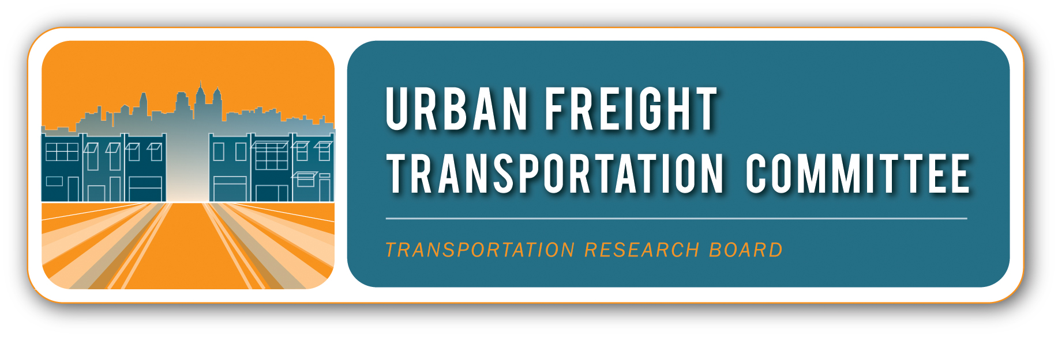
TRB Urban Freight Transportation
Committee Members

Bala Akundi, Baltimore Metropolitan Council
Giorgio Ambrosino, MemEx
Sean Ardussi, Puget Sound Regional Council
Scott Babcock, Transportation Research Board
Maria Boile, Hellenic Institute of Transportation
Ron Borowski, Seattle Department of Transportation
Debbie Bowden, Maryland Department of Commerce
Mike Browne, University of Gothenburg
Joe Bryan, Parsons Brinckerhoff
Linsey Callaghan, Rhode Island Department of Transportation
Arun Chatterjee, University of Tennessee, Knoxville
Tom Cherrett, University of Southampton
Eulois Cleckley, Houston-Galveston Area Council
Alison Conway, City College of New York
Ted Dahlburg, Delaware Valley Regional Planning Commission
Paula Dowell, Cambridge Systematics
Bill Eisele, Texas A&M Transportation Institute
Stacey Hodge, New York City Department of Transportation
Barb Ivanov, Washington State Department of Transportation
Miguel Jaller, University of California, Davis
Michael Kray, Jacobs
Maria Lindholm, Chalmers University of Technology
Vince Mantero, CH2M Hill
Chip Millard, Federal Highway Administration
Roseann O’Laughlin, Oregon Department of Transportation
Yi Lin Pei, Cambridge Systematics
Peter Plumeau, RSG
Fatemeh Ranaiefar, Fehr and Peers
Matt Roorda, University of Toronto
John Tompkins, Minnesota Department of Transportation
Ron van Duin, Delft University of Technology
Cara Wang, Rensselaer Polytechnic Institute
Qian Wang, University of Buffalo
Philbert Wong, Los Angeles County Metropolitan Transportation Authority
Erica Wygonik, RSG
Akiko Yamagami, Southern California Association of Governments
Ema Yamamoto, City of Philadelphia
Hugo Yoshizaki, University of Sao Paulo

Committee friends are welcome!

Visit committee website at:
https://sites.google.com/site/trbcommitteeat025/home

