
TRB Urban Freight Transportation Committee (AT025)

Partnership Presentations
January 11, 2016

Condensed Speaker Bios

- Erika Young (erika.young@t4america.org)
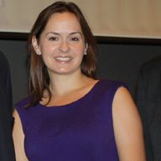
At Transportation for America, Ms. Young manages the organization’s outreach and partnerships program. This includes maintaining relationships with partners, enhancing the quality of customer service, identifying trends and opportunities for new alliances, and developing strategies for raising revenue.
Ms. Young brings over ten years of outreach and legislative experience to the T4America team, building on her past experience in program management, public and constituent service, extensive writing, and advocacy. She comes to T4America from the National Association of Regional Councils, where as transportation director she helped to formulate the organization’s positions on federal transportation legislation and oversaw a coalition advocating on their behalf.

- George Homewood (George.Homewood@norfolk.gov)
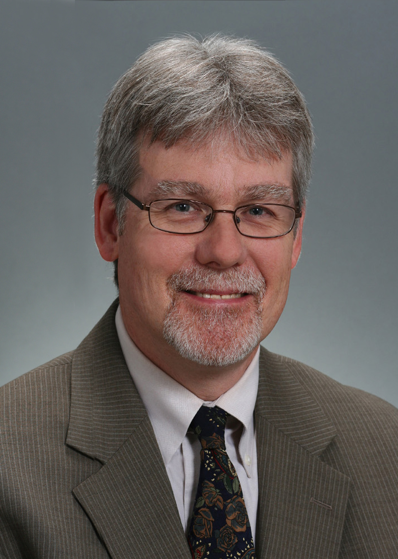
Mr. Homewood is currently the Director of City Planning for the City of Norfolk, Virginia. Previously, he served as Director of Community Development for New Kent County, Chief Planner for York County, and Assistant Planner for James City County. He also was previously employed as a project manager for the U.S. Army and was self-employed as the co-owner of a scuba diving business.
Mr. Homewood is the current President of the American Planning Association’s (APA) Virginia Chapter. Prior to that, he served for four years as Vice-President of Policy & Legislation of the APA Virginia Chapter. He is a member of the APA Legislation & Policy Committee, and co-author of a Hazard Mitigation Policy Guide adopted in 2014 and a Freight Policy Guide scheduled for adoption in April 2016.

over

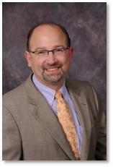
- Douglas Noble (dnoble@ite.org)
Mr. Noble is responsible for the integration of transportation management and operations issues into the Institute of Transportation Engineer’s (ITE) programs, publications and web presence. He has had significant involvement over the past several years on the behalf of ITE in the creation of the National Operations Center of Excellence and the development of its website.

Mr. Noble has more than 25 years of experience in project development, financial management and administration in both the public and private sectors in the transportation engineering field with an emphasis in project management, organizational development and change management, traffic engineering, transportation operations, neighborhood traffic management and planned special events.

- Tamiko Burnell (Tamiko.burnell@dot.gov)
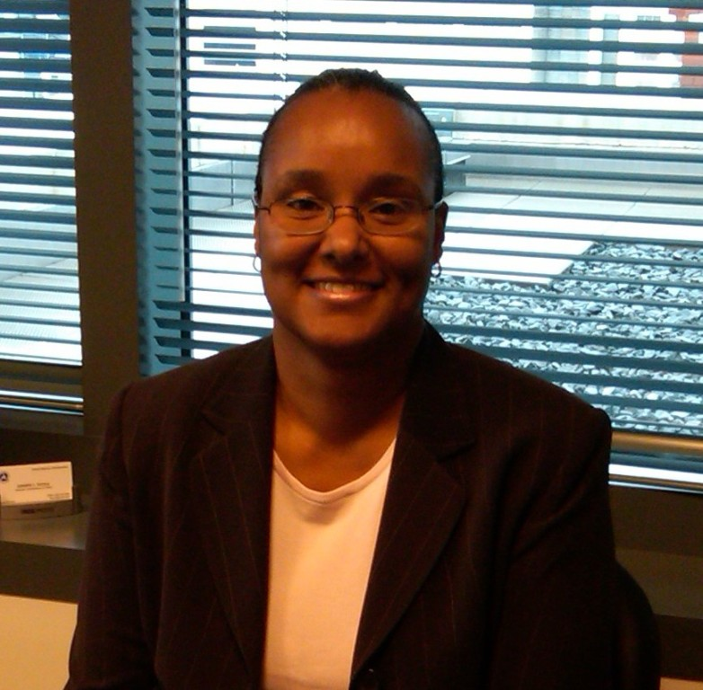
Tamiko Burnell serves as a program manager in the Federal Highway Administration (FHWA), Office of Freight Management and Operations, Freight Program Delivery Team, where she is responsible for the Projects of National and Regional Significance (PNRS) Program, Professional Capacity Building, internal Freight Discipline System, and some freight research activities (Urban Freight Movement).
Ms. Burnell, who is a civil engineer, has 20+ years of service with the federal government. The majority of these years have been spent working for FHWA in the areas of engineering, planning, safety, freight, and technology transfer. In addition to working in the Freight Office, Ms. Burnell has also worked in FHWA’s Office of Safety, Professional and Corporate Development, and the Michigan Division Office.
- Craig Toocheck (craig@nacto.org)
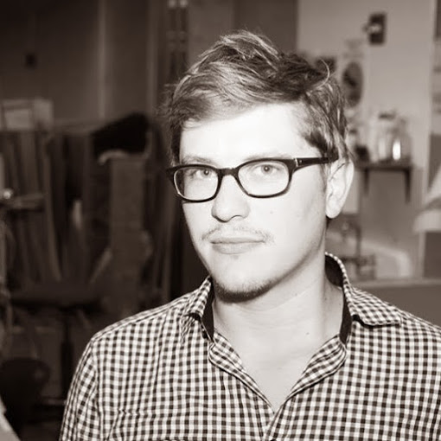
Craig Toocheck is Program Analyst/Designer at the National Association of City Transportation Officials (NACTO), working mainly within the Designing Cities Initiative. Beginning his career at NACTO in July 2014 as a Designing Cities Fellow, he is currently focusing on the creation of the forthcoming Transit Street Design Guide.
Mr. Toocheck is a graduate of UC Berkeley, where he received a Master’s in City Planning, focusing on the nexus between urban design and transportation. Before heading to Berkeley, he received a Bachelor of Science in Architecture from the Catholic University of America in Washington, D.C.; spent a year studying and working in urban planning in Germany as part of the federally-sponsored Congress-Bundestag Youth Exchange program; and worked with a number of planning-related organizations in his native Pittsburgh.

